Name Date of Birth_________________________
Guardian’s name (If under 18):
Your Community: __________________________________________
Phone Number: Address_______________________________________
30 Day Fitness Challenge Rules
- Complete exercise/activity designated for each day of the month.

- You do not have to complete the exercises all at one time. For example: You can complete 15 mountain climbers in the morning of that day and 20 in the evening of that same day.

- Participants under 18 years old must get a parent or guardian to sign the calendar.

- Return completed calendar to CAMP to receive a prize.

I understand and accept the element of risk of physical injury through participation in the 30 Day Fitness Challenges. I further understand there is no medical insurance provided by the Norton Sound Health Corporation or its employees, volunteers, and sponsors for this program. I will assume all risks and I am aware that I shall be responsible for any and all medical costs that may arise from injury through participation in this program as well as any other unforeseen costs that could arise.
I release Norton Sound Health Corporation from any and all liability, loss, damage, costs, claims or causes of action including but not limited to property damage or bodily injuries that may arise from this activity.

(Participant or Parent/Guardian signature) Date
Please return completed calendars to
NSHC CAMP office or email
Kim Gray kgray@nshcorp.org
Questions: Call 443-3365
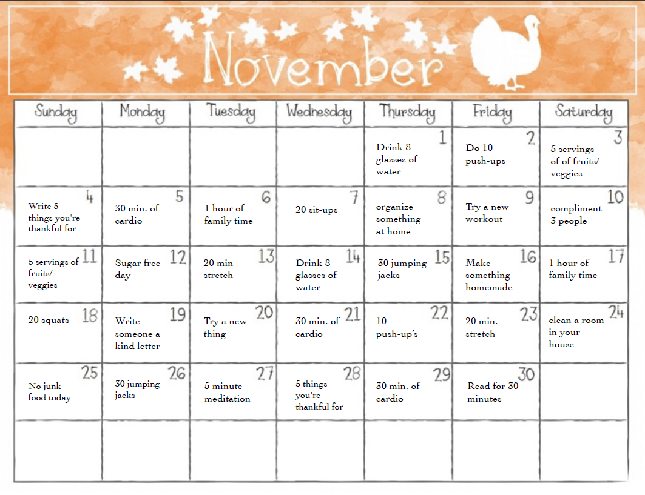
“There is always, always, ALWAYS something to be thankful for”
10 pushups

